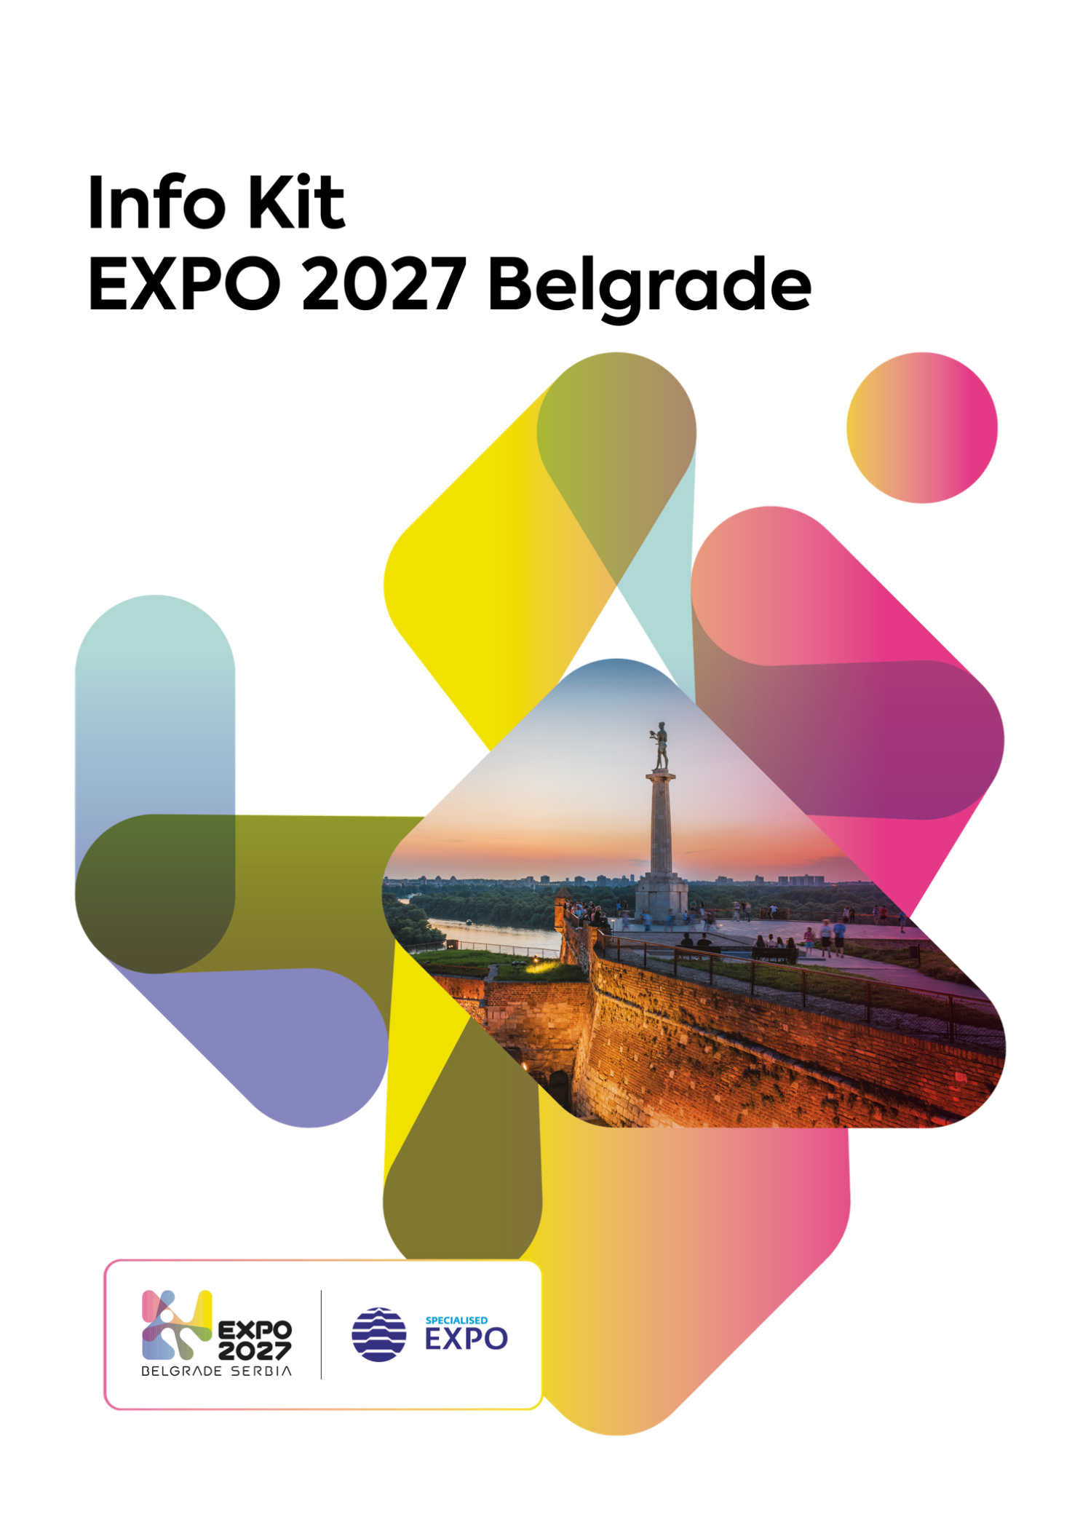
Information on the Specialised Exhibition Expo 2027 Belgrade

BELGRADE AND SERBIA – PROUD HOSTS OF THE SPECIALISED EXPO 2027 BELGRADE

Belgrade and Serbia will proudly host the Specialized Exhibition from 15 May to 15 August 2027. According to preliminary estimates, more than 130 countries, international organizations, and companies will have the opportunity to respond to the theme through a wide range of programmes and activities. Although it had been planned to secure participation confirmations from 100 countries by the end of 2025, this target was achieved seven months ahead of schedule, with more than 130 countries having already submitted their official confirmations of participation. The Exhibition is expected to welcome over four million domestic and international visitors.

The theme of the Specialised Expo in Belgrade is “Play for Humanity: Sport and Music for All”, as it focuses on the importance of play, sport, and music and their contribution to the development of humanity.

SERBIA’S VICTORY – HOST OF EXPO 2027
21 June 2023 – Serbia won the bid to host Expo 2027, prevailing in the strong competition against the United States, Spain, Thailand, and Argentina.
5 September 2024 – The First Deputy Prime Minister and Minister of Finance of the Republic of Serbia Siniša Mali submitted the Recognition Dossier to the Secretary General of the Bureau International des Expositions Dimitri Kerkentzes.
14 October 2024 – At the session of the BIE Executive Committee, a unanimous decision was made to adopt the Expo 2027 Belgrade Recognition Dossier.
26 November 2024 – The Recognition Dossier was adopted at the 175th General Assembly of the Bureau International des Expositions (BIE). On that occasion, the Serbian delegation was presented with the BIE and Expo flag, officially marking the beginning of formal invitations to countries to participate in Expo 2027 Belgrade.
Organising a Specialised Expo is a major development opportunity for Belgrade, Serbia, and the wider region, as well as a chance to promote our country as a tourist and investment destination, and once again demonstrate the traditional hospitality of Belgrade and its citizens.

As Belgrade will become a global hub for the exchange of ideas in 2027, we will have the opportunity to witness the latest technological trends presented at the Expo. It will serve as a platform for Serbia to showcase its innovation and creativity in technological development, such as the BIO4 Campus, sustainable agriculture, artificial intelligence, and high technology. Expo 2027 Belgrade particularly highlights the vital role of play in fostering mutual understanding, driving innovation, and facilitating human interaction.

*The supervision and regulation of International Exhibitions (Expos) falls under the jurisdiction of an intergovernmental organisation called the Bureau International des Expositions (BIE).

THE FIRST EXPO IN THE WESTERN BALKANS REGION


Expo 2027 in Belgrade will be the first International Exhibition ever held in the Western Balkans region, marking a major milestone in the global recognition of the entire area.

Expo 2027 Belgrade – National Pavilion Concept

As the largest event ever organised in Serbia and the region, Expo 2027 aims to set new standards for future International Exhibitions, emphasising the region’s capacity for innovation and hospitality.

The “Play for Humanity” theme is one of the key reasons why Serbia triumphed in the fierce competition against international metropolises. It was exactly the broad and interactive nature of the theme that has inspired a large number of countries - many of which have already expressed interest - not only to participate in Expo 2027, but also to organise various activities enticing the visitors to get involved, which is quite a novelty at International Exhibitions.

The previous Specialised Expo was held in Astana in 2017, gathering participants from 117 countries, which means that Serbia has already, less than two years ahead of the opening of Expo 2027, surpassed Astana in the number of participating countries. The strong interest shown by countries from all over the world in coming to Serbia is the ultimate testament to the immense strength and power of its cultural diplomacy, as well as a clear indicator of the scope and inclusiveness of the main theme of Expo 2027.

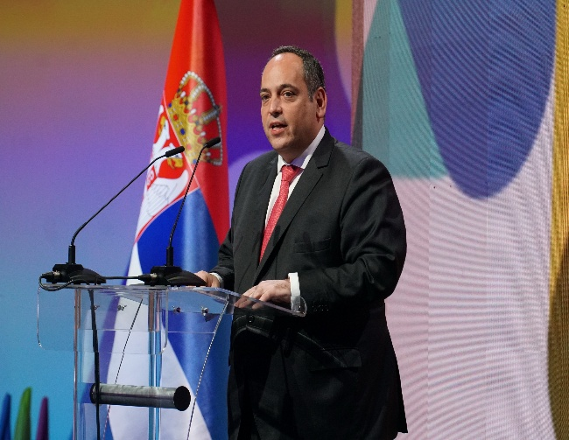
Dimitri S. Kerkentzes,
Secretary General of the Bureau International des Expositions (BIE)

“Organising an Expo is not merely an exercise in planning and hospitality; it is a unique opportunity for a country to present itself to the world in the best possible light. The progress made so far, along with the reports submitted to the BIE Committees and General Assembly, show that Serbia is taking its role seriously and is determined to meet the high standards expected by international participants. Everything indicates that preparations will proceed smoothly, even though some organisational challenges can naturally be expected when hosting the first International Exhibition in the Western Balkans region. I am confident that Expo 2027 Belgrade will be a truly exceptional event with a lasting impact on Serbia, the region, and humanity as a whole.”

INTERNATIONAL EXHIBITIONS AND THEIR SIGNIFICANCE

International Exhibitions are global events that bring the world together in a joint effort to find solutions to the challenges humanity is facing. They provide a platform for presenting new ideas, inventions, and innovations in science, technology, as well as in art, gastronomy, and sport.

Their legacy includes landmarks such as the Eiffel Tower in Paris, the Atomium in Brussels, the Oceanarium, the new fairgrounds in Lisbon, the Ferris Wheel in Chicago, the Magic Fountain of Montjuïc in Barcelona, the Space Needle in Seattle, the First Vienna Mountain Water Supply, and many other globally recognised structures, but also fascinating public parks and a range of scientific and technological breakthroughs, namely television, alternating current, the telephone, skyscraper elevators, touchscreen technology, even the hot dog, peanut butter, iced tea, ice cream cone, and Heinz ketchup.

Although the outcomes and legacies of past International Exhibitions have mostly been infrastructural achievements and scientific or technological milestones, in recent years the themes of these exhibitions have been increasingly focused on pressing global challenges and socially relevant topics, such as sustainable development, food, and energy. Today, more than ever, the world needs a fresh and optimistic outlook on the future. Expos are, by their very nature, ideal venues for dialogue encouraging us all, individually and collectively, to make the world a better place for future generations.

According to BIE regulations, there are four types of International Exhibitions: World Expos, Specialised Expos, Horticultural Expos, and the Triennale di Milano.

Specialised Expos, such as the one that will be held in Belgrade in 2027, are events that offer answers to specific themes related to humanity and last for three months.

The primary reason for hosting not only International Exhibitions but also other large-scale events, as well, is the branding and public visibility they provide to the host city and country. Just like the Olympic Games or the FIFA World Cup, an Expo can significantly enhance the reputation of a destination. In recent times, World Expos have significantly contributed to strengthening the host country's economy, and a good example of this is the People's Republic of China, which hosted the World Expo in Shanghai in 2010. It was the most visited Expo in history, with as many as 73 million visitors.
What Does the Expo 2027 Belgrade Logo Represent?
The inspiration for the now widely recognised Expo 2027 logo came from one specific feature of the host city - Belgrade. “The spirit of Belgrade is best captured at the confluence of the Sava and Danube rivers, with which the city shares a strong, both physical and emotional connection. By analysing water as a form, we came up with a logo that best reflects the play of colours between the two rivers, as well as their constant motion through waves,” says Saša Vidaković, the renowned designer and author of the Expo 2027 visual identity. At the 2025 Graphis Design Awards, the Expo 2027 Belgrade visual identity was awarded the Silver Medal.


SERBIA’S PARTICIPATION IN PAST EXPOS – 140 YEARS OF PRIDE
Serbia’s rich history of participation in International Exhibitions was celebrated with a photo exhibition marking 1,000 days until the opening of Expo 2027 Belgrade. The exhibition showcased some of the most remarkable Serbian pavilions: from the very first participation in 1885, when the Kingdom of Serbia was one of only 12 participating nations at the time, to the well-noticed presentation at Expo 2025 Osaka.
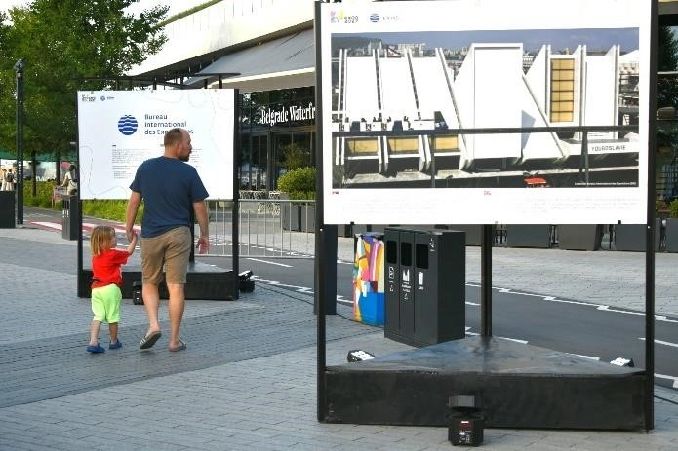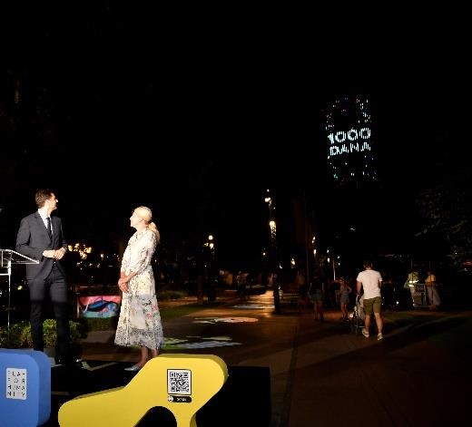

Although Expo is being organised in our country for the first time, Serbia has a long and successful history of participation in International Exhibitions. The first World Exhibition was held in London in 1851, whereas our debut took place long ago in Antwerp in 1885.
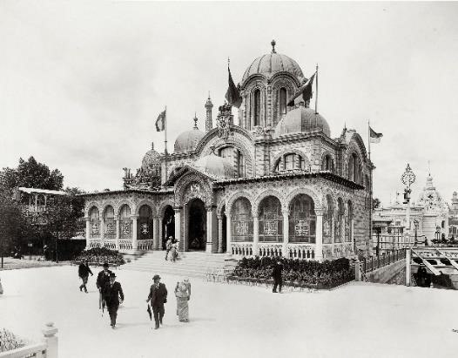

At the World Expo in Paris in 1900, held along the Seine, Serbia made a notable appearance. Our products (food, minerals, textiles) were displayed in a specially constructed 550 m² pavilion, designed in the style of a Serbo-Byzantine church. As the event included awards for exhibition quality, Serbia received as many as 19 gold, 69 silver, and 98 bronze medals.

Expo 1900 Paris – Serbian Pavilion in the Traditional Serbo-Byzantine Style
Later on, Serbia also made a significant impact at the 1958 Expo in Brussels, the event behind the construction of the Atomium, the symbol of Brussels and Belgium, at which time, as Yugoslavia, we attracted major attention with a unique pavilion made from a combination of iron and glass.
In 1967, in Montreal, 90 countries presented their own pavilions, and the architecture of the Yugoslav Pavilion told the story of us, both through its interior content and exterior structure, which featured design elements inspired by the Đerdap Gorge on the Danube and the “Gazela” Bridge in Belgrade.
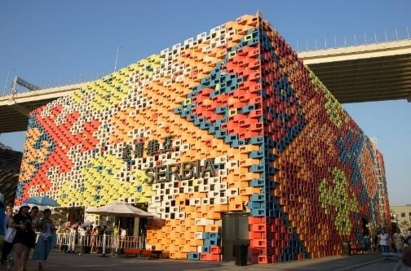
Since 2000, Serbia has participated in four more World Expos — in Shanghai in 2010, in Milan in 2015, in Dubai in 2021, and is currently represented at Expo 2025 Osaka.
Shanghai set a new record for attendance, and Serbia presented its imposing 1,000 m² pavilion, with a facade inspired by the traditional Pirot kilim.

Expo 2010 Shanghai – Serbian Pavilion with a facade in the style of the traditional Pirot kilim
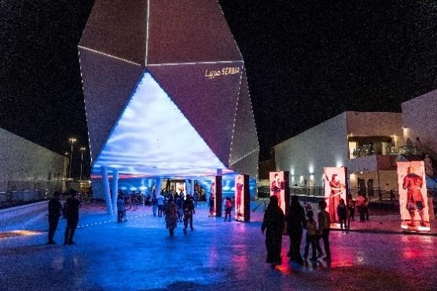
At the World Expo in Dubai, held in the post-COVID period, Serbia’s impressive presentation attracted the attention of more than one million visitors. During Expo 2020 Dubai, Serbia established over 10,000 business contacts and gained global media attention, thanks to its achievements in science and innovation, as well as the participation of renowned Serbian artists and athletes.

Expo 2020 Dubai – Serbian Pavilion

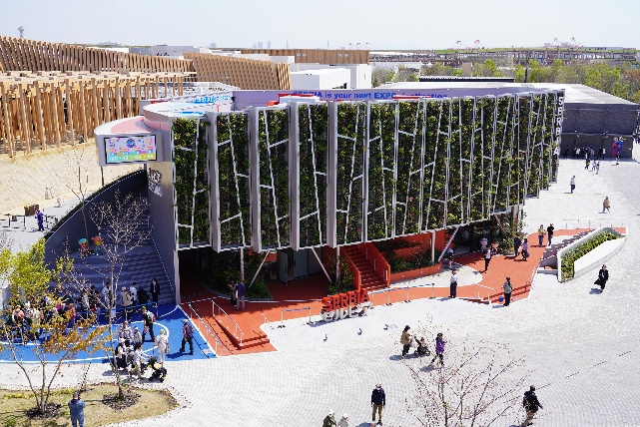
Serbia was the only Western Balkan country with its own pavilion at Expo 2025 in Osaka, which is hosting the World Expo for the second time in history. The Serbian pavilion, shaped like the Great War Island in Belgrade, was one of the greenest, and with its theme "Society of Play", it served as an excellent invitation to Expo 2027 Belgrade, whose official mascots were premiered in Japan. The exhibition Floating Forest at the Serbian pavilion attracted over one million visitors ahead of the Expo’s official closing on 13 October, marking one of the record-breaking levels of attendance. Recognizing both innovation and concept quality, the Serbian Pavilion received two awards: Best Technological Integration and the Silver Medal for Theme Development in the category of self-built pavilions up to 1,500 m².

Expo 2025 Osaka – Serbian Pavilion
EXPO – IMPACT ON HOST CITIES
International Exhibitions significantly enhance the reputation and the image of host cities all over the world. While preparing for an Expo, cities sharpen their own vision of the future. Due to high visitor numbers, exhibitions also attract foreign companies and organisations, new residents, and investments to the host city, and stimulate foreign trade, direct foreign investment, increased presence of international organisations in both the city and the host country, facilitate diplomatic relations, and greatly improve the city’s capacity to host future global events.
One of the main requirements for a successful Expo is its integration with the city and the region, as well as the positive impact it can have on urban development. Previous hosts of International Exhibitions agree on the following benefits: new solutions for mobility and infrastructure, improved quality of life for the local population, a significant increase in attractiveness as a tourist destination, long-term investment across various sectors, and the promotion of a positive global image.
Dimitri S. Kerkentzes, Secretary General of the Bureau International des Expositions (BIE):
“Expo is a global event where host countries showcase their finest ideas, technological innovations, and cultural achievements. For visitors, the experience can feel like a world tour, without crossing a single border. At such events, you have the opportunity to witness future-facing technologies, discover the most innovative solutions to global challenges, and explore a rich tapestry of cultures, arts, and traditions.
This is not merely an exhibition, but an exceptional educational experience that informs, inspires, and entertains. Through interactive displays, thought-provoking exhibits, and unforgettable performances, you gain a deeper understanding of global issues, progress, and the diverse approaches of different nations. You leave enriched with new knowledge and a clearer awareness of just how interconnected our world is and how countries are shaping the future of humanity.”
Major events can also act as catalysts for tourism. According to an OECD (Organisation for Economic Co-operation and Development) study, events are becoming an increasingly important driver of tourism, occupying a prominent role in the development and marketing of most destinations and play an ever-growing part in enhancing a location’s competitiveness.
The organisation of International Exhibitions has significantly contributed to the prosperity of many world cities, most notably Lisbon, Aichi, Astana, Zaragoza, as well as Paris, Chicago, Barcelona, Seattle, and Dubai. As a part of Expo 1998 Lisbon, the Polis Programme was launched, focusing on improving the quality of life in 39 Portuguese cities. For Expo 1970 Osaka, the city upgraded its subway system, railway lines, highways, and airport, fully aware that this would establish it as a global economic competitor. The success is evident - Osaka hosted another World Expo (Expo 2025).

ECONOMIC ASPECTS OF THE SPECIALISED EXPO IN BELGRADE
The total value of Expo 2027 project, including the supporting infrastructure, an Aquatic Centre, a residential complex of 1,500 apartments, the Zemun – Airport – Expo railway, and a new pier on the Sava River, is estimated at €1.29 billion.
Expo 2027 Belgrade will contribute not only to the development of the capital but also to the economy of the entire country. The organisation of the exhibition will lead to increased construction activity, including new hotels, the National Stadium, the Fairgrounds, a river port, and more. It is expected to have a significant impact on Serbia’s GDP, with the greatest influx anticipated through hospitality, tourism, hotel services, and other activities. As a result, this will contribute to a higher economic growth and a stronger economy. The event itself, combined with the investment-grade credit rating recently awarded to Serbia, will attract foreign capital, further positioning Serbia as an increasingly appealing investment destination. Expo 2027 Belgrade will also have a strong impact on employment, leading to the creation of numerous new jobs. Large-scale infrastructure projects will be developed, and with repurposing will continue to serve the city long after the exhibition ends.
Expo 2027 Belgrade will also open new opportunities for young people, enabling them to connect with global innovations and technologies. In addition, through infrastructure development, job creation, and the stimulation of international cooperation, Expo will create a more favourable environment for the young talent to stay and thrive in Serbia.
LEGACY AND SUSTAINABILITY OF EXPO 2027 BELGRADE
For more than 170 years, International Exhibitions under the auspices of BIE have transformed host cities, bringing major infrastructure improvements, as well as a wealth of innovations and some of the greatest scientific and technological achievements of their time. At the Specialised Expo 2027, a flying taxi will be presented as a pinnacle of technology, science, transport, and artificial intelligence.
During the preparations for the upcoming Specialised Expo, a wide range of infrastructure development projects will be implemented. This infrastructure will be built to meet the immediate operational needs of the exhibition, but it also aims to deliver lasting, sustainable benefits to the community.
Sustainability is an integral part of Expos. Planning and preparing an International Exhibition requires consideration of legacy and sustainable solutions for the future use of the Expo Park, infrastructure, and other intangible heritage. Adhering to the principles of sustainability is one of the key elements of organisation overseen by BIE.
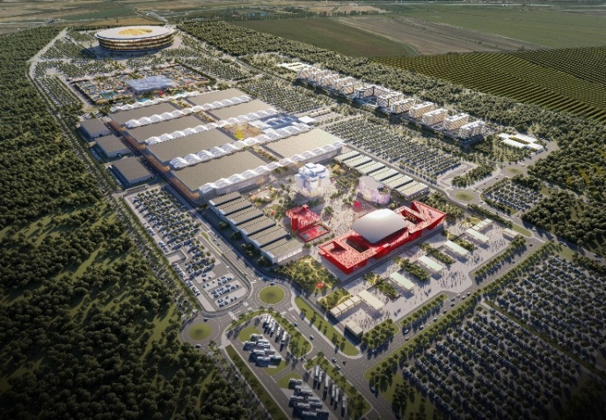
The Expo 2027 Belgrade Master Plan, including the Thematic Area, the International Participants Area, and the Best Practice and Corporate Area, will be 100 per cent legacy, meaning it will be fully repurposed after the end of the exhibition. By implementing best practices in architecture, Serbia aims to set a gold standard, not only in the organisation of mega-events, but also in terms of sustainability and reuse of its legacy.
Expo 2027 Beograd

The Expo 2027 legacy will include the new Belgrade Fair, the Expo 2027 Museum, the Auditorium, the International Forum of Play, the Competence Centre for Innovation and Creativity, the National Centre for the Promotion of Sport and Physical Activity, the Centre for Musical Experimentation, new schools and kindergartens, sports halls, residential areas and hotels, retail facilities, as well as new playgrounds and public spaces. These newly developed facilities, serving as a lasting reminder of Expo 2027, will strengthen Belgrade and Serbia’s future bids to host other global events.

GREEN AGENDA OF EXPO 2027 BELGRADE (Play GREEN, Play for HUMANITY)
Expo 2027 Belgrade will serve as a model of sustainability, with the ambition to raise environmental awareness in Belgrade and across Serbia. From the urban planning approach to the introduction of native plant species that do not require additional irrigation, the project is designed to make a lasting contribution to environmental protection. The Expo Complex will act as a natural filter, processing over 80% of rainwater, which will flow into underground aquifers, a part of Belgrade’s potable water system.
In order to protect the site from potential hazards, such as the floods that struck Serbia in 2014, the terrain level of the wider Expo Zone has been raised by approximately four metres. All inaccessible rooftops will be covered with local plant species in a green roof system not requiring additional watering, reducing solar heat radiation by 20 per cent and lowering the local microclimate temperature by up to four degrees Celsius.
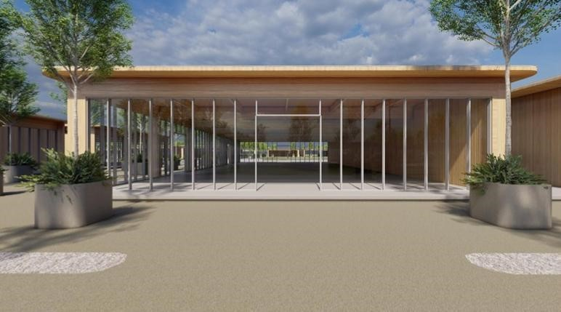
The latest models of environmentally friendly, zero-emission transport will be introduced. The Best Practice Area will be built using locally sourced Serbian wood, with domestic companies engaged in its construction. After the exhibition, this area will be dismantled, and the materials reused for educational institutions, sports halls, and public parks. This means that about one-quarter of the Expo Complex will be designed as a modular structure, which will be repurposed for the construction of schools and kindergartens after the exhibition.
Best Practice Pavilion
All these elements contribute to the broader goal of making Expo 2027 Belgrade carbon neutral, and a source of inspiration for future sustainable initiatives.

PRE-EXPO PERIOD
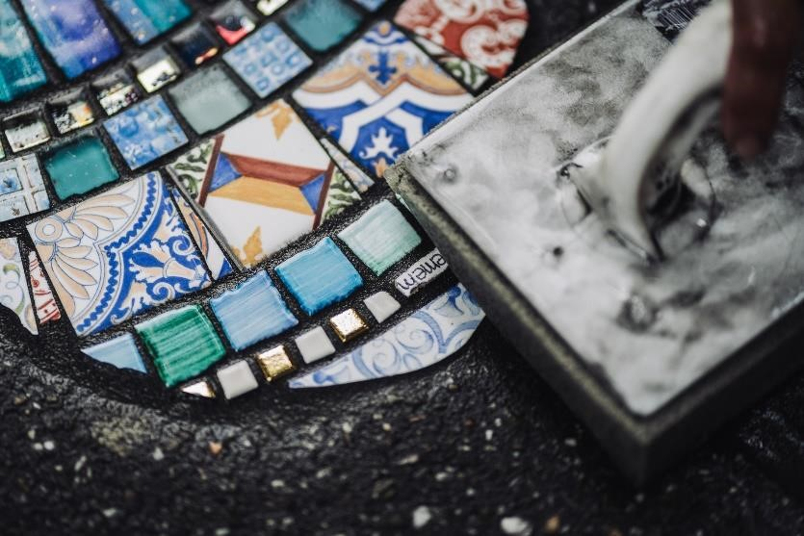
In the lead-up to Expo 2027 Belgrade, numerous activities are planned. Some of these include artistic interventions across various Serbian cities, aimed at raising public awareness of the exhibition, whereas others promote the “Play for Humanity” concept by introducing structured play in educational institutions to communicate the values and significance of play to the wider public. The outcomes of these activities will be presented during the event through indoor and open-air installations. By offering diverse experiences before and after the main event, Expo pushes the boundaries of time and space, extending beyond its physical site and reimagining its conventional framework. The spirit of play will begin long before the opening ceremony, and will continue afterward through its museum-style legacy.
Just as sport and music bring people together, public art unites communities, inviting collective participation and interaction, reflecting playfulness, creativity, and inclusiveness, i.e. values that deeply resonate with the Expo ethos. Through these artistic transformations, Expo 2027 Belgrade becomes more than an International Exhibition - it becomes a living canvas where art and culture thrive. Each mural, sculpture, and installation tells a story, adding layers of meaning to city streets and celebrating both the global and local spirit of Belgrade. Urban interventions provide new ways to experience the city, where every corner may reveal a surprise and every street has a new story to tell.
In this context, Expo 2027 will not only showcase global cultures, cutting-edge technology, and worldwide innovations, but will also celebrate the power of art to redefine space, foster connection, and inspire playful interaction. These interventions capture the very essence of an Expo event - creativity, unity, and the transformative power of human expression in shaping the future of our cities.
These artistic works are only the beginning of a larger cultural movement leading up to the Specialised Expo 2027. They reflect Belgrade’s openness to new artistic expressions while respecting its urban heritage. Through the upcoming Expo Caravan, communication about the largest global event in the Western Balkans will be extended across Serbia with the aim of ensuring that every citizen can take pride in the fact that Serbia has been given the opportunity to welcome the world in 2027!

WHAT CAN WE EXPECT IN THE UPCOMING PERIOD?
At the end of 2024, the President of the Republic of Serbia sent official invitation letters to heads of state, inviting them to participate in Expo 2027 Belgrade. Confirmations of participation and expressions of interest from countries across the globe are arriving daily. The first countries to confirm their participation include Switzerland, Turkey, China, Russia, Italy, Germany, and a large number of nations from Africa and the Pacific. Although the initial plan was to receive confirmations of participation from 100 countries by the end of 2025, that goal was reached - and even surpassed – 7 months earlier. In the upcoming period, other interested countries are also expected to formally signal their commitment to participation by sending their confirmations back to Serbia via official highest-level diplomatic channels.
Once confirmations are received, individual discussions with each country will begin about the design, content, and approach to how they will present themselves in line with the official theme.
In August 2025, the Republic of Serbia and the Bureau International des Expositions (BIE) signed the Agreement on Privileges and Benefits Necessary for the Participation in the Expo 2027 Belgrade (SEE Agreement), which constitutes the binding legal foundation of every International Exhibition under the auspices of the BIE.
The SEE Agreement, signed at the Expo 2027 Playground in Hall 5 of the Belgrade Fair by the First Deputy Prime Minister and Minister of Finance of the Republic of Serbia, Siniša Mali, and the Secretary General of the BIE, Dimitri Kerkentzes, is a key document on the path to the successful organisation of Expo 2027 and represents Serbia’s international obligation, in accordance with the 1928 Paris Convention relating to International Exhibitions and the established practice of the BIE.
Previously adopted at the BIE General Assembly session in June this year, this document provides the international legal framework for the arrival and work of foreign delegations, the construction of pavilions, the establishment of legal entities for the participating countries in Serbia, the opening of their business bank accounts, the recognition of driving licences, the movement of goods, tax and customs exemptions, and defines the legal status of the Expo 2027 Belgrade Participants.
The first step following the signing of the SEE Agreement, in line with the local legal procedures, is its ratification by the National Assembly of the Republic of Serbia. However, immediately after the signing, and before ratification, the Republic of Serbia may proceed with signing Participation Agreements with each individual Expo 2027 Participant.
Once the Agreement enters into force after ratification, the Government of the Republic of Serbia will adopt the necessary by-laws and technical solutions for its implementation. Following all these steps, Participants may register their temporary legal entity - the Office of the Commissioner General - with the Serbian Business Registers Agency, which maintains a special Register for this purpose. Only through this procedure can the Offices of the Commissioner General enjoy the privileges and benefits provided for under the Agreement.
In July 2025, the Expo 2027 Playground was opened in Hall 5 of the Belgrade Fair - the first physical space dedicated to the Specialised Expo 2027. Conceived as a playground of ideas, a meeting place of imagination and vision, the Expo 2027 Playground offers visitors a unique opportunity to experience the values that will shape Expo 2027 Belgrade through multimedia content, thematic installations, and a dynamic programme. This space already embodies the spirit of the exhibition through openness, creativity, and dialogue.
Over the next two years, the Playground will come alive through a series of activities such as workshops, exhibitions, and diverse events, creating a network of knowledge, cooperation, and innovation leading towards 2027. The Expo 2027 Playground is not only an introduction to the major exhibition, but also the first step in a movement that transcends borders and unites humanity through play, ideas, and a shared vision of the world we live in.
June 2025 marked the first International Planning Meeting (IPM), which brought together more than 400 delegates from more than 150 registered and potential participating countries. The event was held in Belgrade, where attendees were introduced to the venue, the organising team, and the services available to support their countries’ participation in Expo 2027. The delegates left Serbia with positive impressions, praising the flawless organisation and expressing great enthusiasm to begin their preparations for Expo 2027. The next IPM is scheduled for March 2026.
The signing of participation agreements commenced in November, with the Slovak Republic, the Russian Federation, and the Islamic Republic of Iran among the first countries to conclude these agreements, thereby enabling the implementation of further operational steps for their participation at Expo 2027.The whole world is currently getting to know the official Expo 2027 mascots, the charming characters of a boy and a girl representing both traditional and modern aspects of Serbia with a public voting for their names is currently underway. Citizens had the opportunity to decide what the mascots would be called, aiming to select names that reflect the spirit and identity of Expo 2027, Belgrade and Serbia—and their names are Rastko and Milica!


We invite you to be a part of Expo 2027 Belgrade
and join us in proving the true POWER OF PLAY!

More information is available at the official Expo 2027 Belgrade website: https://expobelgrade2027.org

